**NORTHEASTERN UNIVERSITY**

**INFORMATION SYSTEMS FALL ’19**



**DENTAL OFFICE**

***BUSINESS REQUIREMENTS***

DATA MANAGEMENT & DATABASE DESIGN

INFO6210 - 09

**Guided By:** **Created By:**

Prof. Vincent Lattuada Group 10: Phoenix

TABLE OF CONTENTS

REVISION HISTORY 4

INTRODUCTION 4

AUDIENCE 5

HIGH LEVEL DIAGRAM 5

MAIN SUBJECT AREAS 6

PROVIDER 6

PATIENT 6

APPOINTMENT/TREATMENT 6

EQUIPMENT/SUPPLIES 6

BILLING/INSURANCE 7

PRESCRIPTION 7

ACCOUNT/SYSTEM AREA 7

ENTITIES AND ATTRIBUTES 8

DENTIST **Error! Bookmark not defined.**

PATIENT 8

APPOINTMENT 12

LICENSE **Error! Bookmark not defined.**

DENTIST SPECIALIZATIONS 13

ROOM 14

INSURANCE COMPANY 14

TREATMENT SUMMARY 15

PATIENT HISTORY 15

EXAMINATION RECORD 16

INVOICE 16

PATIENT INSURANCE CLAIM 17

BUSINESS RULES 20

IN SCOPE 20

ACCOUNT CREDENTIALS / ROLE 20

PROVIDER 21

LICENSE 21

PROVIDER SPECIALIZATION 21

PROVIDER CONFIDENTIAL DETAILS 21

PATIENT 21

PATIENT HISTORY 21

APPOINTMENT 21

ROOM 21

TREATMENT CATALOG 22

INSURANCE 22

INVOICE 22

PRESCRIPTION 22

OUT OF SCOPE 23

HUMAN RESOURCE AND PAYROLL 23

SUPPLIES 23

EMERGENCIES 23

FEEDBACK 23

APPOINTMENT RESCHEDULE 23

THIRD PARTY VENDORS 23

PATIENT MEMBERSHIP 23

THIRD PARTY REFERENCE 23

DENTIST RATINGS 23

ENTITY RELATIONSHIP DIAGRAM 24

DEFINITIONS AND ABBREVIATIONS 24

# REVISION HISTORY

|  |  |  |  |
| --- | --- | --- | --- |
| **Version** | **Changes Made** | **Created Date** | **Author** |
| v1.0 | Initial Draft | 12th Nov, 2019 | Kinnari Sanghvi |
| v1.1 | Created Entities and Clusters | 13th Nov, 2019 | Tanvi Tembhurne |
| v1.2 | Added Business Rules | 14th Nov, 2019 | Jayshil Jain |
| v1.3 | ER Diagram and High Level Diagram | 15th Nov, 2019 | Tilak Parmar |

# INTRODUCTION

This document is being written in context with the business requirements of the dental office database management system. We are creating a system to support the scheduling, treatment and billing of patients at a dental office. The database management system will help the dental office to keep track of the necessary details of all patients and dentists. It is also designed to track each and every transaction related to the appointments. The system also looks towards the different specializations of a dentist and helps patients choose a dentist according to their requirement. The database also stores the patient’s history details, if any, which can help the dentist in giving proper treatment to the patient.

This system looks towards the different specializations of a dentist and helps patients choose a dentist according to their requirement. The patient can book appointments with the dentists for preferred date and time. We enforce that the patient can only book one appointment at any specific time. The database saves various appointment details like date and time, location, and status of the appointment. We will also have patient history where all the appointments of the patient will be saved for future references. This will help dentists to give appropriate treatment to the patients. There will be a treatment catalog which will track all the treatments. The appointments may contain one or more treatments. The invoice generated will be the summation of charges applied for all the treatments done in that scheduled appointment. Thus, we will have all the references to the appointment entity in this system. There will be a database table for prescription as well which will be holding all the prescription details provided to the patient in an appointment.

The system also allows the patients to claim their insurance, although from a limited insurance companies which the office supports. The system accepts payments in cash, check, card and insurance claims. It allows the office to track the status of claims and work in an orderly fashion to acquire the amount from insurance companies. The system also supports some functionalities which might be added as the model grows. Such as, the system can also be designed to store all the location details of the dental office in case it operates at multiple locations. Also, the system can help to generate timely notifications for equipment maintenance, cleanliness and giving pay outs to its employees if the business requires it to.

This system will provide an organized solution for the dental office and help it function in a well-structured way. This system takes into consideration all the aspects related to the appointment of a patient with a dentist. However, this system fails to consider any other entities which is not related either directly or indirectly to the patient’s treatment. The employee details like the assistants, nurses and their salary payments are not to be taken into consideration. The list of supplies and equipment used at the office is also not taken care of yet. However, this system still takes enough rules and entities into consideration so that it can deliver a sufficient amount of experience to a patient. Hence, this system provides a prodigious solution to the dental office for its successful operation and providing satisfactory treatment to people visiting the dental office.

# AUDIENCE

* Database Administrators
* Web Developers
* Project Managers
* Logistics Manager
* Patients
* Dentists
* Dental Equipment Manufacturers
* Dental Insurance Companies

# HIGH LEVEL DIAGRAM

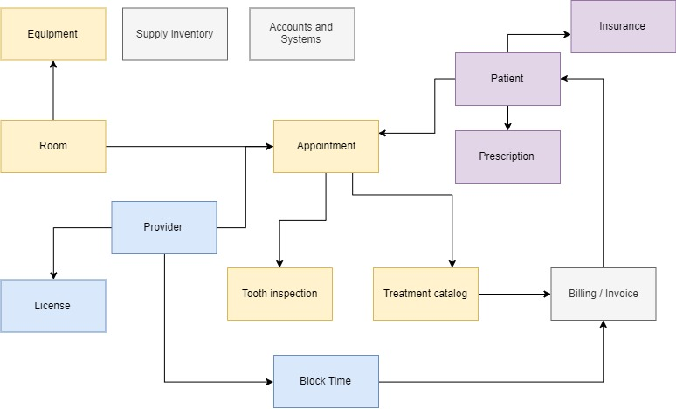

# MAIN SUBJECT AREAS

## PROVIDER

The provider cluster is where information regarding the care givers at the dental facility will be housed. Information captured here will include the data necessary to allow for a provider to perform work on behalf of the facility. Insurance information, licenses, specializations and general demographic information will be kept in this area. This section should support the other areas within the stem with regards to caregivers such as providing services and obtaining reimbursement for the services. The confidential documents of the dentist such as his SSN and bank account details will also be tracked in this subject area. The entities involved in this subject area are:

* Dentist
* License
* Specializations
* Confidential Documents
* Provider’s Block-Time

## PATIENT

The patient cluster houses the details of person who has/had scheduled an appointment to get a treatment at the dental office. This is where the information regarding the care receiver at the dental office will be housed. Medical history of the person receiving the dental care will be kept in this area. Details of the patients’ insurance claims should not be tracked under this cluster. The confidential documents of the patients such as their SSN, bank account details and insurance details will also be tracked in this cluster. The entities involved in this subject area are:

* Patient
* Patient History
* Medical Issues
* Confidential Documents

## APPOINTMENT/TREATMENT

The appointment cluster stores the details of the meeting between the dentist and the patient. The date and time of the meeting, the location and room number where the appointment will be held all information can be found from this cluster. The summary of the treatment given to the patient by the dentist at a specific appointment will also be maintained in this cluster. It also includes the diagnostic information and patient related communications that occur during the appointment. The examination record after each examination regarding the oral cancer, plaque, tongue and gums will also be taken care of in this cluster. The entities involved in this subject area are:

* Appointment
* Treatment Summary
* Examination Record
* Room

## EQUIPMENT/SUPPLIES

This cluster houses the information of the equipment and regular day to day supplies available in the room where the appointment is scheduled. All the details of the equipment present inside these rooms will be contained in this cluster. Equipment details contains all the major equipment present in the room that will contribute towards the care of the patient. The regular supplies which are used in day to day care of the patients such as gloves and other small utilities will be tracked inside this cluster. The entities involved in this subject area are:

* Equipment
* Supplies

## BILLING/INSURANCE

The billing and insurance related entities will be included in this cluster. The patient has the option of paying by cash, card, check or insurance. When the patient decided to claim his insurance, then the insurance entities will come into play. The companies supported by the dental office is tracked in this cluster. Each and every claim and its amount will be contained under this cluster. This cluster should support the dental office with respect to the income generated from the treatments. The dentist charges for the time he gave towards the care of the patient. This time will be divided in blocks as per the office’s requirement. The patient would be charged as per the time-block used for the care. The entities involved in this subject area are:

* Invoice
* Patient Claim Insurance
* Insurance Companies
* Time Block

## PRESCRIPTION

The data of the prescriptions given by the dentist will be housed in this cluster. A prescription can or cannot be generated for every appointment but every prescription will be linked to one and only one patient. This cluster will be held as an individual entity and will contain the list of medicines prescribed by the dentist. It will be also be containing the pharmacies from where the patient is set to collect his prescribed medicines. The time duration for which the patient needs to take the medications will be also be tracked in this cluster.

* Prescription

## ACCOUNT/SYSTEM AREA

There would be a specific set of people who will be authorized to access this database system. The account and system area cluster comprises of the login credentials of the user and their roles in the dental office. This cluster will also be required to maintain the active status of the currently working employees. Administrator will be responsible for providing/revoking the authorizations and this cluster will maintain the credential details of the administrators as well as of the providers and other users of this system.

* Account Credentials
* Role

# ENTITIES AND ATTRIBUTES

## PROVIDER

**Definition**:

The provider is defined in this context as the person who provides any kind of dental services. It can be a dentist, hygienist or an assistant. The provider entity’s purpose is to hold data that is specific to the dentists, hygienist and assistants which helps in identifying it uniquely like provider’s name, license and specialization.

This tables help in classifying the provider by specialization.

|  |  |  |  |  |
| --- | --- | --- | --- | --- |
| **Business Name**  **(Attribute Name)** | **Data Type** | **Key / Null** | **Definition** | **Sample Data** |
| Provider ID (ProvID) | Integer | PK / Unique | Unique ID generated upon insertion into table. Helps to uniquely identify the provider | 3542 |
| Provider Name (ProvName) | Varchar (100) | NN | Provider name which will be displayed to the user | Dr. John Doe |

## Provider Details Entity

**Definition**:

This  Provider_Details contains all the personal details of the provider.

### The Provider_Details entity’s purpose is to hold data that is specific to the provider’s personal details like address, phone number, gender, email ID and date of birth.

**Attributes**

|  |  |  |  |  |
| --- | --- | --- | --- | --- |
| Business Name(Attribute Name) | Data Type | Key / Null | Definition | Sample Data |
| Provider Details ID (PID) | Integer | PK / Unique | Unique ID generated upon insertion into table. Helps to uniquely identify the provider | 3542 |
| Provider Address Line1 (PAddressL1) | Varchar (200) | NN | defines provider’s address line 1 | AB street, Apt x |
| Provider Address Line2 (PAddressL2) | Varchar (200) | NN | defines provider’s address line 2 | Boston, MA |
| Provider Phone number (PPhone) | Number | Nullable | defines provider’s phone number | xxxxxxxxxx |
| Provider Gender (PGender) | Char (1) | Nullable | defines provider’s gender | F |
| Provider Email (PEmail) | Varchar (50) | Nullable | defines provider’s email ID | xyz@email.com |
| Provider Date of birth (ProvDOB) | Date | NN | defines provider’s date of birth | 11/22/1990 |

## Provider_Confidential Entity

**Definition**:

This  Provider_Confidential contains all the confidential details like SSN and tax Identification number. The Provider_Confidential entity’s purpose is to hold data that is specific to the provider’s confidential details like SSN and TIN. It will be used for salary and tax return purposes. The data saved inside this table will be encrypted for security reasons.

**Attributes:**

|  |  |  |  |  |
| --- | --- | --- | --- | --- |
| Business Name(Attribute Name) | Data Type | Key / Null | Definition | Sample Data |
| Provider Confidential ID (CID) | Integer | PK / Unique | Unique ID generated upon insertion into table. Helps to uniquely identify the record | 3542 |
| SSN (C_SSN) | Varchar (50) | NN | defines provider’s SSN (C IS01) | 345-443-3333 |
| Tax Identification Number (C_TIN) | Varchar (50) | NN | defines provider’s Tax Identification Number (C IS02) | 22AAAAA00AA1Z5 |

### 

## PATIENT

**Definition:**

This entity houses the details of person who has/had scheduled an appointment to get a treatment at the office. It is linked to the Dentist entity after an appointment is scheduled. A patient will be have its own patient’s history as well as a history with its preferred dentist.

**Attributes:**

|  |  |  |  |  |
| --- | --- | --- | --- | --- |
| **Business Name** | **Data Type** | **Constraints** | **Definition** | **Sample Data** |
| Patient ID (PatientID) | Integer | PK / Unique | Unique ID generated upon insertion into table. Helps to uniquely identify the patient | 1212 |
| Patient Name (PatientName) | Varchar (100) | NN | Patient name will be stored for future references (PAT IS01) | Lorem Doe |
| Patient Address (PatientAddress) | Varchar (300) | NN | This attribute will save patient’s address  (PAT IS02) | ABC street, Apt x, Boston, MA |
| Patient Phone (PatientPhone) | Varchar (30) | NULL | This attribute will save patient’s contact (PAT IS03) | xxxxxxxxxx |
| Patient Gender (PatientGender) | Char (1) | NN | This attribute will save patient’s gender (PAT IS04) | F |
| Patient Email (PatientEmail) | Varchar (50) | NULL | This attribute will save patient’s email (PAT IS05) | 5,27,89,890 |
| Patient Date of birth (PatientDOB) | Date | NN | This attribute will save patient’s date of birth (PAT IS06) | 11/22/1990 |
| Emergency Contact (EmergencyContact) | Varchar (30) | NULL | This attribute will save patient’s emergency contact for emergency cases | xxxxxxxxxx |

## LICENSE

**Definition:**

Every dentist is licensed by the state they are operating in to perform dentistry. This entity stores the licenses’ details of the dentists working at the dental office. This entity is linked to dentists’ entity. A dentist can have more than one specializations and its details can be found in the licenses table.

**Attributes:**

|  |  |  |  |  |
| --- | --- | --- | --- | --- |
| **Business Name** | **Data Type** | **Constraints** | **Definition** | **Sample Data** |
| License ID (LicenseID) | Integer | PK / Unique | Unique ID generated upon insertion into table. Helps to uniquely identify the License | 1234 |
| License Number (LicenseNumber) | Varchar | NN | License number of the provider (LIC IS01) | 6734689788 |
| License Specialization(Specialization) | Varchar (30) | NN | A specialization name used to classify providers as Dentist, hygienist or an assistant | Dentistry |
| License Expiration Date(LicenseExpiry) | Date | NN | License expiration date of the provider (LIC IS03) | 10/21/2019 |

## APPOINTMENT

**Definition:**

This entity stores the date and time of the meeting scheduled between a dentist and a patient. It also stores the location and room number where the appointment will be held. A patient can be having multiple appointments with the same dentist at the same location. This entity is linked with the treatment summary entity to store the important points discussed between the patient and the dentist.

**Attributes:**

|  |  |  |  |  |
| --- | --- | --- | --- | --- |
| **Business Name** | **Data Type** | **Constraints** | **Definition** | **Sample Data** |
| Appointment ID (AptID) | Integer | PK / Unique | Unique ID generated upon insertion into table. Helps to uniquely identify the appointment | 3542 |
| Appointment name(AptName) | Varchar (100) | NN | Defines problem mentioned by patients while booking the appointment (APT IS01) | Tooth ache |
| Appointment Date(AptDate) | DateTime | NN | Defines appointment date and time (APT IS03) | 12-10-30-12:34:56 |
| Appointment Status(AptStatus) | Char (1) | NN | Status can take values as Booked(B), Cancelled(X), no show(N), done(D) (APT IS04) | B |
| Appointment notes (AptNotes) | Varchar (200) | NULL | Defines appointment notes for the treatment provided to the patient in this appointment (APT IS05) | Need clean up every 2 months |
| Provider ID (ProvID) | Integer | FK/NN | A unique number that references the provider of the service for this appointment. The complete details of the provider can be found in his own table by using this number. (PROV IS06) | 1212 |
| Patient ID (PatID) | Integer | FK/NN | A unique number that references the patient who has booked the appointment. The complete details of the patient can be found in his own table by using this number.(PAT IS07) | 3465 |
| Room ID (RoomID) | Integer | FK/NN | A unique number that references the room in which the appointment is held. The complete details of the patient can be found in his own table by using this number. | 1254 |

## EQUIPMENT

**Definition:**

## There are many

**Attributes:**

|  |  |  |  |  |
| --- | --- | --- | --- | --- |
| **Business Name** | **Data Type** | **Constraints** | **Definition** | **Sample Data** |
| Equipment ID (EquipID) | Integer | NN / PK | Unique ID generated upon insertion into table. Helps to uniquely identify the equipment. | 1212 |
| Equipment Name (EquipName) | Varchar | NN | Includes the equipment name | X-Ray |
| Maintenance date (MaintenanceDate) | Date | NULL | Contains the next maintenance date | 11-12-2019 |

## SUPPLIES

**Definition:**

## There are many

**Attributes:**

|  |  |  |  |  |
| --- | --- | --- | --- | --- |
| **Business Name** | **Data Type** | **Constraints** | **Definition** | **Sample Data** |
| Supply ID (SupplyID) | Integer | NN / PK | Unique ID generated upon insertion into table. Helps to uniquely identify the supply item | 1212 |
| Supply Name (SupplyName) | Varchar | NN | Includes the supply name | gloves |
| Supply Quantity (SupplyQty) | Integer | NN | Include the number of supplies in the inventory | 10 |

## DENTIST SPECIALIZATIONS

**Definition:**

## There are many concentrations in which a dentist can specialize. The list of all such concentrations in which the dentists of the dental office have specialized, are housed in this entity. It is linked to the License entity, so every dentist has to have a valid license in order to work and accept appointments for that specialization.

**Attributes:**

|  |  |  |  |  |
| --- | --- | --- | --- | --- |
| Attribute Name | Data Type | Constraints | Definition | Sample Data |
| Specialization_ID | Int | PK | This attribute uniquely identifies each specialization | 2 |
| Specialization | Varchar(100) | Not Null | This attribute contains information about the specialization supported at the dental office | Endodontist |

## ROOM

**Definition:**

This entity stores the details of the place at which the appointment between the patient and dentist has been scheduled. It also stores the data of the facilities that the room has. Many appointments can be scheduled in the same room.

**Attributes:**

|  |  |  |  |  |
| --- | --- | --- | --- | --- |
| **Business Name** | **Data Type** | **Constraints** | **Definition** | **Sample Data** |
| Room_ID | Int | PK | This attribute uniquely identifies each room where the appointments can be held | 210 |
| Room No (RoomNo) | Int | NN / Unique | Defines the room number | 2 |

## INSURANCE

## **Definition:**

This entity houses the details of all the companies that the dental office supports to claim the patient’s insurance. These companies provide dental coverage to patients at the dental office. This is linked with the Patient’s insurance entity to track the claims. Claim amount and invoices are not represented in this entity.

**Attributes:**

|  |  |  |  |  |
| --- | --- | --- | --- | --- |
| **Business Name** | **Data Type** | **Constraints** | **Definition** | **Sample Data** |
| Insurance ID (InsID) | Integer | PK / Unique | Unique ID generated upon insertion into table. Helps to uniquely identify the insurance | 3542 |
| Insurance company (InsCompany) | Varchar (100) | NN | Defines the insurance company | BlueCross BlueShield |
| Insurance number (InsNumber) | Varchar (100) | NN | Defines the unique insurance number provided to the patient by the insurance company | NUQ736452728 |

## TREATMENT SUMMARY

**Definition:**

This entity stores the summary of the treatment given to the patient by the dentist at a specific appointment. It includes the diagnostic information, clinical notes, treatment performed and patient related communications that occur during the appointment.

**Attributes:**

|  |  |  |  |  |
| --- | --- | --- | --- | --- |
| **Attribute Name** | **Data Type** | **Constraints** | **Definition** | **Sample Data** |
| Treatment_Performed | Varchar(255) | Not Null | This attribute contains the details of the treatments performed by the dentist for a particular appointment | Root Canal on tooth 19 |
| Notes | Varchar(255) | Null | This attribute contains the notes of the dentist if dentist wants to mention something post appointment | Follow up after 15 days |
| Prescription | Varchar(255) | Null | This attribute contains the prescription given by the dentist | DentTabs125, BioTene Paste |
| ExaminationRecord_ID | Int | FK | This attribute acts as a reference to the primary key of Examination Record Entity | 798 |
| Appointment_ID | Int | FK / Not Null | This attribute acts as a reference to the primary key of Appointment Entity | 2 |

## PATIENT HISTORY

**Definition:**

This entity is related to the patient and stores the information gathered by asking a particular set of questions to the patient during his first visit. This data also gets updated over time, if need arrives. This data will be used by the dentist while giving any treatment to the patient in future.

**Attributes:**

|  |  |  |  |  |
| --- | --- | --- | --- | --- |
| **Attribute Name** | **Data Type** | **Constraints** | **Definition** | **Sample Data** |
| Visit_Reason | Varchar(255) | Not Null | This attribute contains the patients reason for visiting the dental office | Root Canal |
| Medical_Problems | Varchar(255) | Null | This attribute contains any medical problems that the patient has | High BP |
| Previous_Surgeries | Varchar(255) | Null | This attribute contains the list of surgeries performed on the patient | Impacted Wisdom Tooth, Dental Implants |
| Patient_ID | Integer | FK | This attribute acts as a reference to the primary key of Patient Entity | 21 |

## EXAMINATION RECORD

## **Definition:**

## The dentist keeps a record of all the examinations performed on the patient’s mouth, teeth, tongue and gums. All the details of the examination record is stored in this entity. The dentist can keep track of a patient’s affected teeth or if an oral cancer has been detected. This entity is linked to the Appointment entity as well as the Patient entity to keep a track of a treatment’s progress. The dental office has the option of storing a scanned copy of the examination record and also individually store details of the record.

**Attributes:**

## INVOICE

|  |  |  |  |  |
| --- | --- | --- | --- | --- |
| Attribute Name | Data Type | Constraints | Definition | Sample Data |
| Tooth_id | Int | PK Not Null | Tooth ID will hold the tooth_Id as per the standards defined in the international system. | 1890 |
| Crown_Level | Char(1) | Null | Crown Level will be set true if operated on crown level | Y |
| Root_Level | Char(1) | Null | Root Level will be set true if operated on crown level | Y |
| Neck_Level | Char(1) | Null | Neck Level will be set true if operated on crown level | N |
| Cavity | Char(1) | Null | Yes if Cavity is Present | Y |
| Plague | Char(1) | Null | Yes if Plague is Present | N |
| Stains | Char(1) | Null | Yes if Stains is Present | N |
| Abstraction | Char(1) | Null | Yes if Abstraction is Present | N |
| CrackedTooth | Char(1) | Null | Yes if Cracked Tooth is Present | Y |
| Appointment_ID | Int | PFK / Not Null | This attribute stores the number of the third most affected tooth of the patient | 3 |
| Room_ID | Int | PFK / Not Null | This attribute stores the number of the most affected tooth of the patient | 4 |
| Prov_ID | Int | PFK / Not Null | This attribute provides a reference to the primary key of Appointment Entity | 112 |
| Patient_ID | Int | PFK / Not Null | This attribute acts as a reference to the primary key of Patient Entity | 445 |

## **Definition:**

## This entity houses the amount of money charged to the patient for each appointment. It is given out in a printed or written statement of charges. The patient has an option of paying the bill through card/cash/cheque/insurance. Every appointment will be having at least one invoice generated for it.

**Attributes:**

|  |  |  |  |  |
| --- | --- | --- | --- | --- |
| **Attribute Name** | **Data Type** | **Constraints** | **Definition** | **Sample Data** |
| InvoiceNumber | Int | Int | This attribute uniquely identifies each and every invoice | 8765 |
| Amount | Int | Default Value: 0 | This attributes states the bill amount charged by the patient in US Dollars | 500 |
| Payment_Mode | Varchar(10) | Values IN (Check, Cash, Card, Insurance) | This attribute states the mode of payment used by the Patient to pay the bill | Insurance |
| Summary | Varchar(255) | Null | This attribute provides a summary of the total bill incurred by the patient for that particular appointment | Appointment Charge: 100, Tooth Removal: 400 |
| Appointment_ID | Int | FK / Not Null | This attribute provides a reference to the primary key of Appointment Entity | 1 |
| Insurance_Claim_ID | Int | FK / Null | This attribute provides a reference to the primary key of Patient Insurance Claim entity only if the Payment_Mode is 'Insurance' | 2 |

## PATIENT INSURANCE CLAIM

## **Definition:**

This entity houses the details of amount to be claimed from the insurance company which is providing dental coverage to the patient. The claim number, insurance company and the amount to be claimed are represented in this entity.

**Attributes:**

|  |  |  |  |  |
| --- | --- | --- | --- | --- |
| **Attribute Name** | **Data Type** | **Constraints** | **Definition** | **Sample Data** |
| InsuranceClaim_ID | Int | PK | This attribute is used to uniquely identify the claim amount and its associated company | 1 |
| ClaimAmount | Big Int | Null | This attribute stores the amount of money in US Dollars to be claimed from the insurance company | 2000 |
| Company_ID | Int | FK / Not Null | This attribute provides a reference to the primary key of Insurance Company entity | 2 |

## Treatment Catalog (Treatment)

## **Definition:**

The treatment entity is defined in this context to store the treatments done by the dentists

## **Attributes:**

|  |  |  |  |  |
| --- | --- | --- | --- | --- |
| **Attribute Name** | **Data Type** | **Key / Null** | **Definition** | **Sample Data** |
| Treatment ID (TrID) | Integer | PK / Unique | Unique ID generated upon insertion into table. Helps to uniquely identify the treatment | 3542 |
| Treatment name (TrName) | Varchar (100) | NN | Defines treatment name **(TR IS01)** | Clean up |
| Treatment charge (TrCharge) | Money | NN | Defines the charge applied for the treatment | $50 |

## Invoice Entity (Invoice)

## **Definition:**

## The invoice entity is defined in this context to store the bill generated for every scheduled appointment.

## **Attributes:**

|  |  |  |  |  |
| --- | --- | --- | --- | --- |
| **Attribute Name** | **Data Type** | **Key / Null** | **Definition** | **Sample Data** |
| Invoice ID (InvID) | Integer | PK / Unique | Unique ID generated upon insertion into the table. Helps to uniquely identify the invoice | 3542 |
| Insurance Claimed | Integer |  | The amount of Insurance claimed by the patient to the Insurance Company for the policy they have taken from the Insurance Company | 2000 |
| Payment Type | Varchar(20) | NN | There various payment type available in the system like Cheque or Credit Card or cash or Insurance | Cash |

## Prescription

## **Definition:**

The prescription Entity is used to store prescription of all the patients with respect to their appointments.

## **Attributes:**

|  |  |  |  |  |
| --- | --- | --- | --- | --- |
| **Attribute Name** | **Data Type** | **Key / Null** | **Definition** | **Sample Data** |
| Prescription ID (PrescriptionID) | Integer | NN / PK | Unique ID generated upon insertion into table. Helps to uniquely identify the Prescription **(PRE IS01)** | 1212 |
| Prescription (Prescription) | Image | NN | Include the image of prescription **(PRE IS01)** | Image |
| Pharmacy | Varchar(50) | NN | Includes the pharmacy | CVS |

## Account Entity :

## **Definition:**

The account entity is used to store username and passwords of all the members of the system such as dentists, patients and admin.

## **Attributes:**

|  |  |  |  |  |
| --- | --- | --- | --- | --- |
| **Attribute Name** | **Data Type** | **Key / Null** | **Definition** | **Sample Data** |
| PersonID | Integer | NN / PK | Unique ID generated upon insertion into table. Helps to uniquely identify the Account holder | 1212 |
| Username(Entity) | varchar | NN | Include the image of prescription **(PRE IS01)** | Image |
| Password(Entity) | Varchar(50) | NN | Includes the pharmacy | CVS |

## Role

**Definition**:

The role table will have the contents of what roles are to be assigned to what user_id. For instance, a patient will only get a partial access to his/her own records while a dentist gets access to all the patient records but not access to other dentist records. The admin of the system will be having all the access of the system.

|  |  |  |  |  |
| --- | --- | --- | --- | --- |
| Attribute Name | Data Type | Key/Null | Definition | Sample Data |
| Role_ID | varchar(25) | PK / Not Null | Role ID will be unique id for each type of role in the system. | D123 |
| Role_Name | varchar(25) | Not Null | Role Name will define the name of the role in the system. | Dentist |

# BUSINESS RULES

## IN SCOPE

### ACCOUNT CREDENTIALS / ROLE

IS01: A person is able to use the system if he/she is authorized to with valid username and password, different users can access different parts of the system which they authorized to, like reception cannot access prescription or billing, she/he is only allowed to access appointment.

### PROVIDER

IS02: provider table stores all the demographic details and sub divided into whether the provider is a dentist or assistant or hygienist.

IS03: The dentist will be directly linked to Licenses and Appointment tables.

IS04: The dentist table should be linked with the License table. A dentist can have more than one license. If the dentist does not have a valid License, he/she is not allowed to practice at the dental office.

IS05: The dentist can also choose to work at another location if the dental office has multiple locations.

### LICENSE

IS06: Every dentist should be having a state approved dentist license. If a dentist does not have/not yet submit a valid license, he is not allowed to practice at the dental office or take appointments.

IS07: The license details are added in the Licenses table and it is linked with the Dentist entity. Every dentist should be having at least one valid license.

### PROVIDER SPECIALIZATION

IS08: A provider can have a specialization, if provider has one then its details will be stored in this table.

IS09: The dental office can offer treatment to the patients of the specializations which are entered in this entity. If a dentist with the required specialization is not present at the office, then the dental office cannot take appointment for the patient.

IS10: A dentist can have multiple specializations, and each dentist has to have one specialization linked to its valid license in order to take appointments.

### PROVIDER CONFIDENTIAL DETAILS

IS11: Confidential data such as SSN, Credit Card Number, etc. only of Dentist should be stored in separate reference table with more security applied to the table.

### PATIENT

IS12: Patient entity will store all the demographic details with an attribute called Emergency Contact Number.

IS13: This table will be directly linked to the Patient’s History entity when a new entry is created under the Patient table.

IS14: The patient entity will also store the preferred dentist of the patient. So, if the patient wishes to book an appointment, the system will try to book his appointment with the preferred dentist first and then look for other dentists.

### PATIENT HISTORY

IS15: Should records all the medical as well as financial details related a patient in the dental office.

IS16: This entity cannot be updated once it is added.

### APPOINTMENT

IS17: The Dentist is linked to the Patient entities only when an appointment is scheduled between that dentist and patient.

IS18: If there is no appointment booked between a dentist and a patient, Appointment table remains empty.

IS19: Patient can have one or more treatments per appointment.

IS20: A patient can book multiple appointments but with different timestamp.

IS21: The appointment should have a location to avoid appointment clashes.

### ROOM

IS22: Each and every appointment is going to be conducted in a room of the dental office. Multiple appointments can be held in the same room but at different timeslots.

IS23: For an appointment, a dentist can choose to change the room, but the patient cannot.

### TREATMENT CATALOG

IS24: A Dentist creates his own Treatment Catalog that will have all the treatment details with a specific price assigned to it.

IS25: This will also include details related to tooth like Number of tooth on which treatment is done, what treatment it done but this can be left blank in accordance with the provided treatment by the Dentist.

### INSURANCE

IS26: The dental office stores the names of all Insurance Companies from which it accepts the patient claims. The dental office cannot support claims from an insurance company which is not added in this table.

IS27: If the patient’s insurance company is not mentioned in the insurance company entity, no entry should be made in this entity.

### INVOICE

IS28: The system must add charge for all the treatments given in the appointment.

IS29: Each and every appointment will be having at least one invoice generated for it. The patient can choose to pay through Cash, Card, Check or Insurance Claim.

### PRESCRIPTION

IS30: Written document by the doctor to authorize patient to have the prescribed drugs or medicines.

IS31: In an Appointment only one prescription is given which will be saved in this Table.

IS32: This Table will also have nearest Pharmacy details for pick up.

IS33: A patient can get a prescription without an appointment.

## OUT OF SCOPE

### HUMAN RESOURCE AND PAYROLL

OS01: Information regarding the payroll and human resource information is not taken into account in this system. This system fails to consider all the employees and assistants working at the dental office who do not count directly towards a patient’s treatment.

OS02: The salaries of the dentists and the employees working at the dental office is not taken into consideration. Only the bills generated for the appointments taken by a dentist are noted in this system.

### SUPPLIES

OS03: The system does not take into consideration the equipment and supplies available at the dental office. It runs by the assumption that all the facilities required by a dentist are already present when a room is booked.

### EMERGENCIES

OS04: This system does not treat the patients of an emergency appointments at the dental office. The emergency appointments are reflected in the appointments table as a normal appointment.

### FEEDBACK

OS05: The system does not take feedback of the patients into consideration yet. The patient can verbally provide his/her feedback about the services at the dental office but that isn’t stored anywhere in the system.

### APPOINTMENT RESCHEDULE

OS06: The system is not designed to deliberately consider a reschedule of an appointment. If need arrives, the existing appointment is cancelled and a new appointment will be created.

### THIRD PARTY VENDORS

OS07: The system does not keep a record of the different vendors with which it deals for supplies, maintenance and other things as they are not related to the patient’s treatment directly.

### PATIENT MEMBERSHIP

OS08: The dental office does not keep a record of patients who regularly book appointments with their dentists. If any discount is offered to the patient, it is directly reflected in the invoice table.

### THIRD PARTY REFERENCE

OS09: There is no scope of third: party reference in this Model, this model is strictly restricted between Dentist and Patient and entities connecting them.

### DENTIST RATINGS

OS10: Dentist is not a hotel, restaurant or dish, which it ought to have feedback of ratings in a star by patients.

# ENTITY RELATIONSHIP DIAGRAM

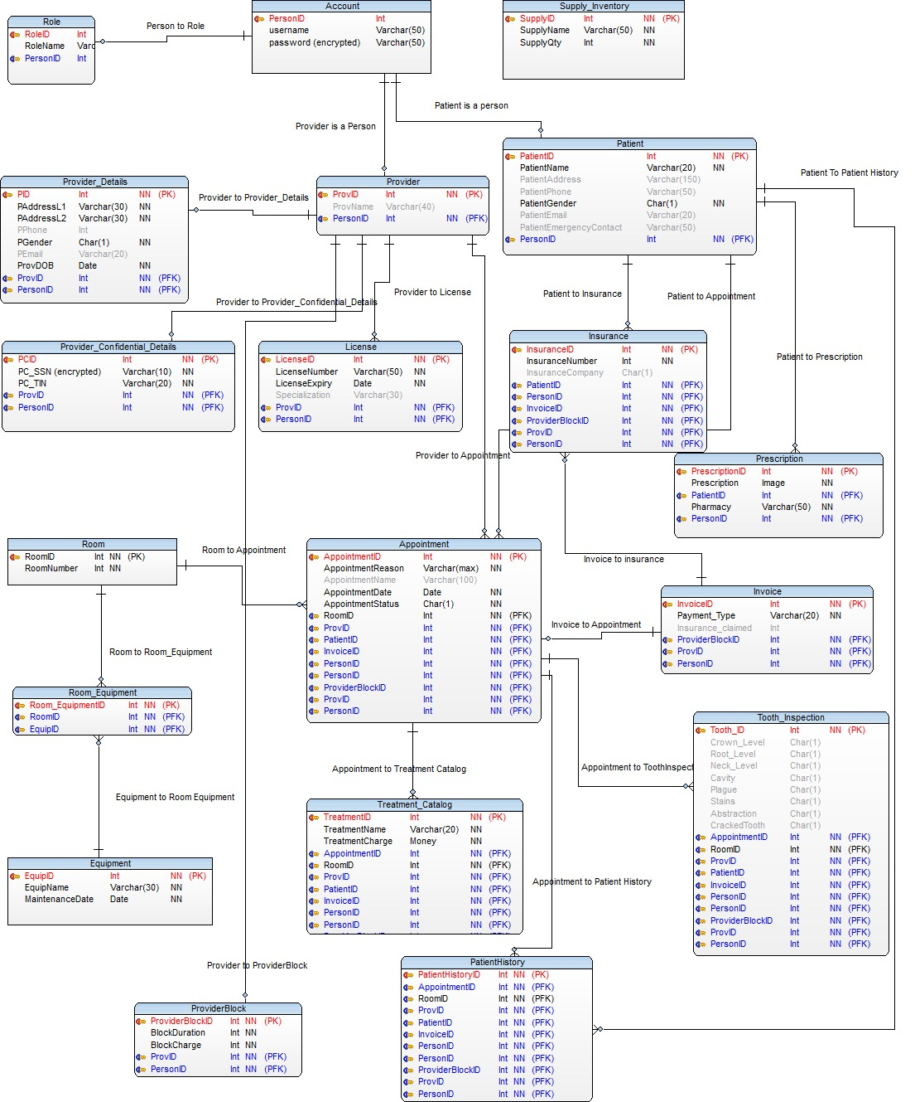

# DEFINITIONS AND ABBREVIATIONS

1. BLOB – Binary Large Object
2. CK – Candidate Key
3. CLOB – Character Large Object
4. CRUD – Create, Read, Update, and Delete
5. DB – Database
6. DBA – Database Administrator
7. DBMS – Database Management System
8. FK – Foreign Key
9. INT – Integer
10. IS – In Scope
11. MONEY – Money format
12. OS – Out of Scope
13. PK – Primary Key
14. NN – Not Null
15. NULL – Empty value that is not defined
16. VARCHAR – Variable Character Field